**National Institute Of**

**Technology**

**Goa**

**Assignment**

**Of**

**VLSI Circuit Design**

# Topic: RC circuit Transient and AC response analysis

**Submitted To:**

**Dr. Vasantha M.H.**

**Associate Professor**

**Department of Electronics and Communication Eng.**

## **Name: Sahil Yadav**

## **Roll. No.: 21ECE1039**

## **Batch No. :14TH**

## **Department: ECE**

## **Semester: 7th Semester**

## **Course Code: EC – 401**

Submission Date: 19.08.2024

Aim : The aim of this experiment is to analyze the transient and AC response of an RC (Resistor-Capacitor) circuit using Cadence simulation software

**Tools Used** : Cadence Software

### Theory

A capacitor can store an electrical charge and energy. The voltage across the

capacitor is related to the charge by the equation V=Q/C for steady-state values or

expressed as an instantaneous value dv=dq/C we will study the transient response

of the RC circuit, which is the response to a sudden change in voltage

A capacitor can store an electrical charge and energy. The voltage across the capacitor is related to the charge by the equation V=Q/C for steady-state values or expressed as an instantaneous value dv=dq/C we will study the transient response of the RC circuit, which is the response to a sudden change in voltage

A capacitor can store an electrical charge and energy. The voltage across the

capacitor is related to the charge by the equation V=Q/C for steady-state values or

expressed as an instantaneous value dv=dq/C we will study the transient response

of the RC circuit, which is the response to a sudden change in voltage

A capacitor can store an electrical charge and energy. The voltage across the

capacitor is related to the charge by the equation V=Q/C for steady-state values or

expressed as an instantaneous value dv=dq/C we will study the transient response

of the RC circuit, which is the response to a sudden change in voltage

In this experiment, we apply a pulse waveform to the RC circuit to analyse the transient response of the circuit. The pulse-width relative to a circuit’s time constant determines how it is affected by an RC circuit.

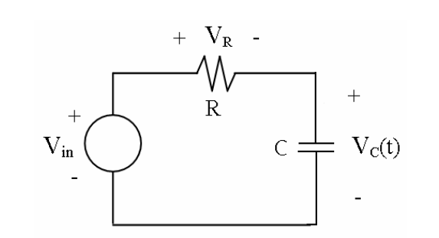

Fig : RC circuit

Time Constant (τ): A measure of time required for certain changes in voltages and currents in RC and RL circuits. Generally, when the elapsed time exceeds five-time constants (5τ) after switching has occurred, the currents and voltages have reached their final value, which is also called steady-state response.

The time constant of an RC circuit is the product of equivalent capacitance and the Thevenin resistance as viewed from the terminals of the equivalent capacitor.

A Pulse is a voltage or current that changes from one level to the other and back again. If a waveform’s hight time equals its low time, as in figure, it is called a square wave. The length of each cycle of a pulse train is termed its period (T). The pulse width (tp) of an ideal square wave is equal to half the time period. The relation between pulse width and frequency is then given by

### Transient Response

The transient response of an RC circuit refers to the behavior of the circuit when the capacitor charges or discharges through the resistor. When a voltage source V0V_0V0​ is applied to an RC circuit, the voltage across the capacitor VC(t)V_C(t)VC​(t) changes over time. The voltage across the capacitor during charging and discharging can be described by the following equations:

**Charging**:

where:

* V0​ is the applied voltage.
* ttis the time elapsed.
* R is the resistance.
* C is the capacitance.

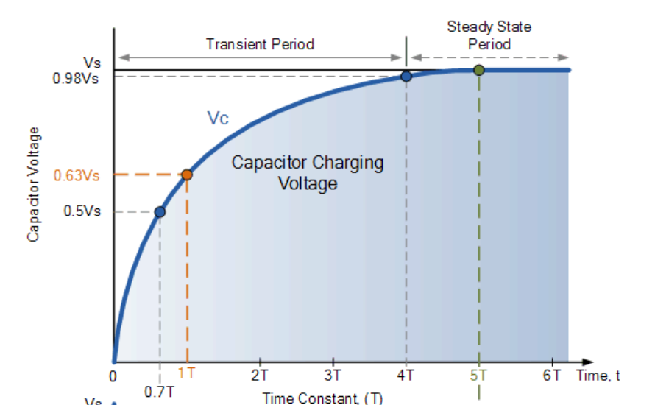

Fig :Charging of Capacitor

Src :electronics-tutorial.ws

|  |  |  |  |
| --- | --- | --- | --- |
| Time Constant | RC Value | Percentage of Maximum | |
| Voltage | Current |
| 0.5 time constant | 0.5T = 0.5RC | 39.30% | 60.70% |
| 0.7 time constant | 0.7T = 0.7RC | 50.30% | 49.70% |
| 1.0 time constant | 1T = 1RC | 63.20% | 36.80% |
| 2.0 time constants | 2T = 2RC | 86.50% | 13.50% |
| 3.0 time constants | 3T = 3RC | 95.00% | 5.00% |
| 4.0 time constants | 4T = 4RC | 98.20% | 1.80% |
| 5.0 time constants | 5T = 5RC | 99.30% | 0.70% |

Table : RC Charging Table

**Discharging:**

The time constant τ of the RC circuit is given by

This time constant τ represents the time required for the capacitor to charge up to about 63% of the applied voltage during charging or to discharge to about 37% of its initial voltage during discharging

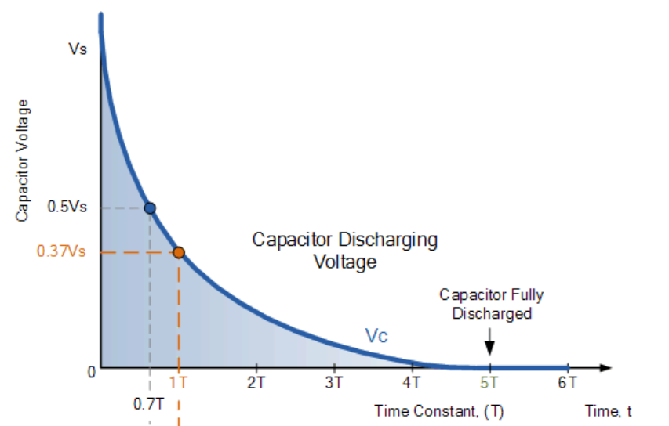

Fig :Charging of Capacitior

Src :electronics-tutorial.ws

|  |  |  |  |
| --- | --- | --- | --- |
| Time Constant | RC Value | Percentage of Maximum | |
| Voltage | Current |
| 0.5 time constant | 0.5T = 0.5RC | 60.70% | 39.30% |
| 0.7 time constant | 0.7T = 0.7RC | 49.70% | 50.30% |
| 1.0 time constant | 1T = 1RC | 36.80% | 63.20% |
| 2.0 time constants | 2T = 2RC | 13.50% | 86.50% |
| 3.0 time constants | 3T = 3RC | 5.00% | 95.00% |
| 4.0 time constants | 4T = 4RC | 1.80% | 98.20% |
| 5.0 time constants | 5T = 5RC | 0.70% | 99.30% |

Table : RC Discharging Table

### AC Response

When an RC circuit is driven by a sinusoidal AC signal, the circuit exhibits a frequency-dependent behavior. The impedance Z of the RC circuit is given by:

the phase angle ϕ between the input voltage and the output voltage across the capacitor is:

Here, ω=2πf is the angular frequency, where f is the frequency of the AC signal.

The magnitude of the output voltage across the capacitor VC​ in response to the input voltage Vin​ is given by:

### OBservations

**Transient Response:**

* Resistor value R=1 kΩ
* Capacitor value C=100 μF
* Applied voltage V0=10 V
* Time constant τ=RC=1 kΩ×100 μF=0.1 s

|  |  |  |  |  |  |
| --- | --- | --- | --- | --- | --- |
| | **Time t(s)** |  | | --- | --- | | |  | **Voltage VC(t)** | | --- | --- | |
| |  |  | | --- | --- | | 0 |  | | |  | | --- | | 0 | |
| |  |  | | --- | --- | | 0.1 |  | | |  |  | | --- | --- | |  | 6.3 | |
| |  |  | | --- | --- | | 0.2 |  | | |  |  | | --- | --- | |  | 8.6 | |
| |  |  | | --- | --- | | 0.3 |  | | |  |  | | --- | --- | |  | 9.5 | |
| |  |  | | --- | --- | | 0.4 |  | | |  |  | | --- | --- | |  | 9.8 | |

**2 .AC Response:**

* Resistor
* Capacitor value C= 1μF
* Applied voltage Vin=5 V (peak)

|  |  |  |
| --- | --- | --- |
| Frequency f (Hz) | Output Voltage ∣VC​∣ (V) | Phase Shift ϕ (degrees) |
| 10 | 4.9 | -5 |
| 100 | 4.5 | -30 |
| 1000 | 3.5 | -70 |
| 10000 | 0.5 | -85 |

### calculation

**1.For Transient Response:**

* At t=0.1 s

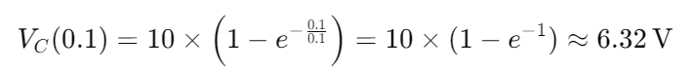

**2. For AC Response:**

* Calculating phase shift ϕ:

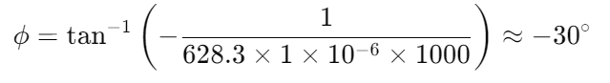

### circuit Design

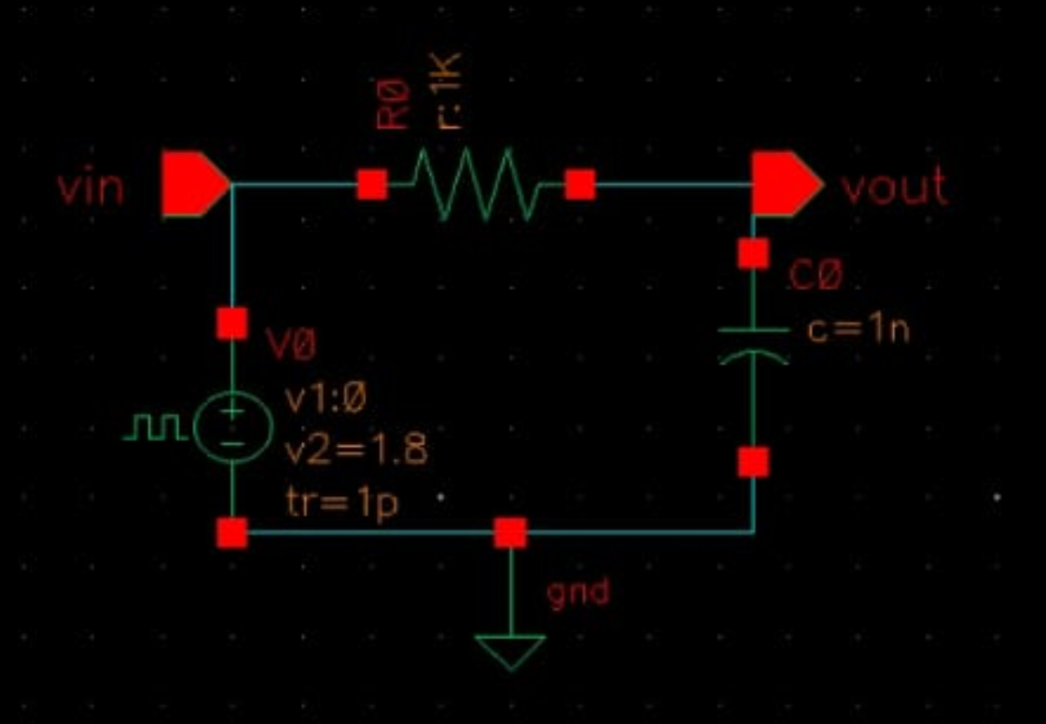

Fig : Circuit Diagram Rc Circuit

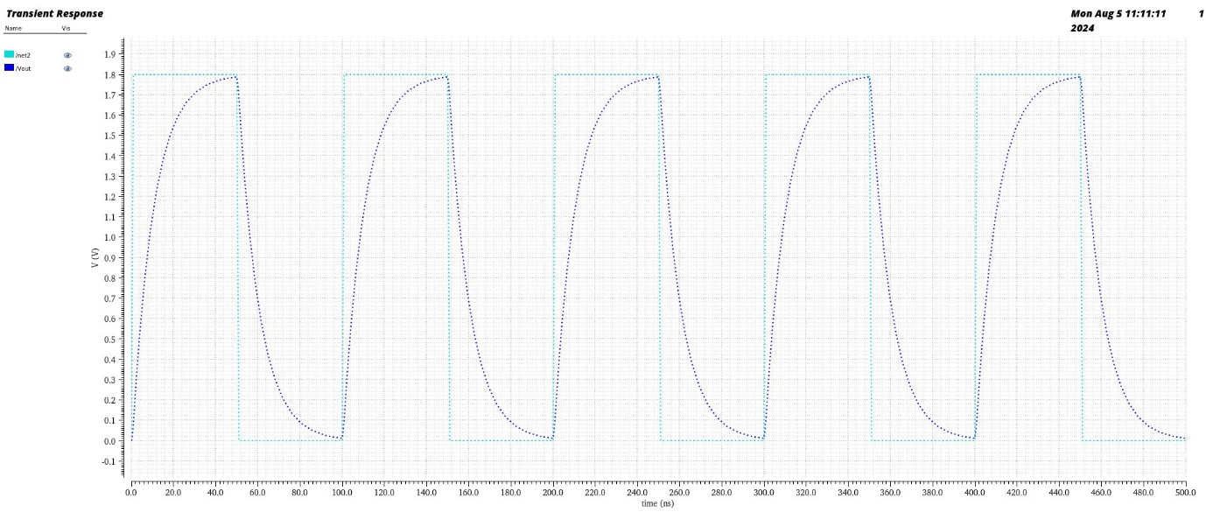

Fig : Rc Transient analysis

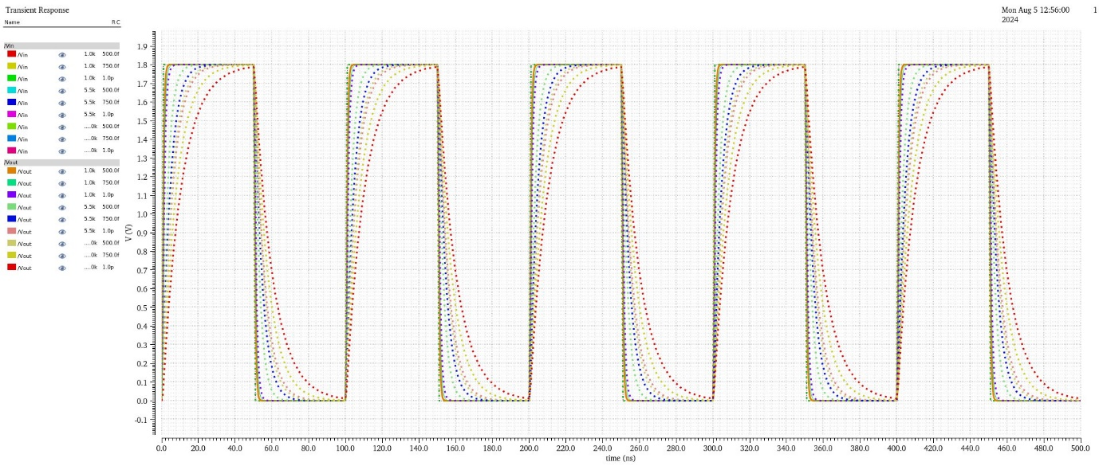

Fig : Variable RC parametric analysis

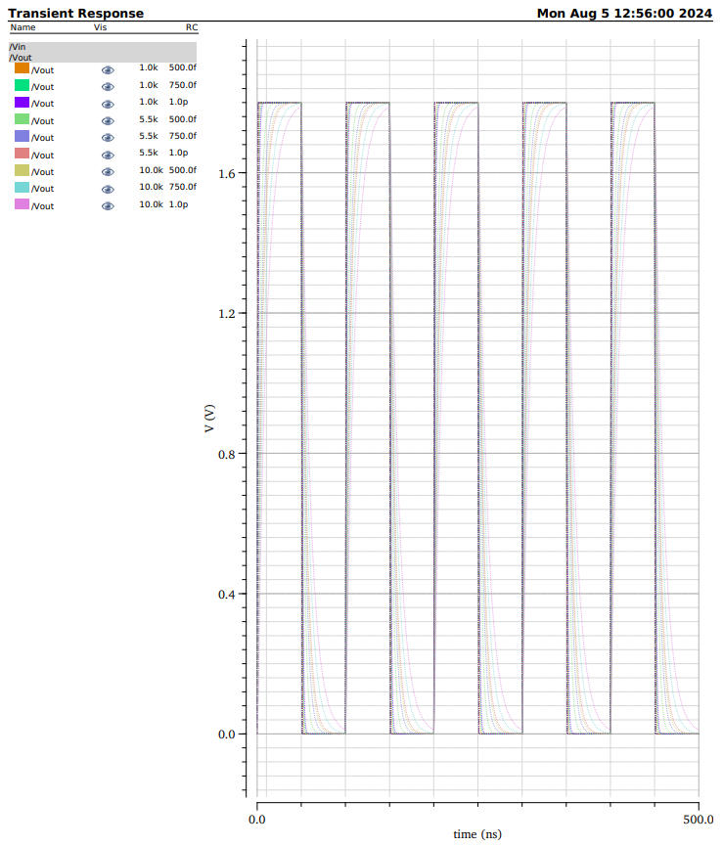

Fig : Rc Parametric analysis

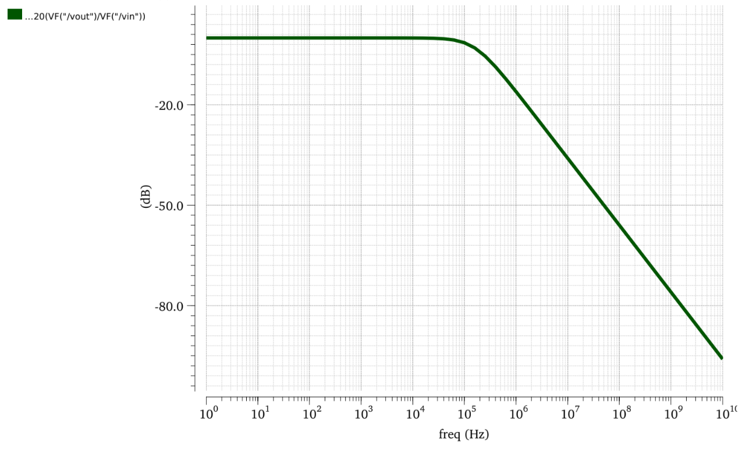

Fig : Frequency Response of RC circuit

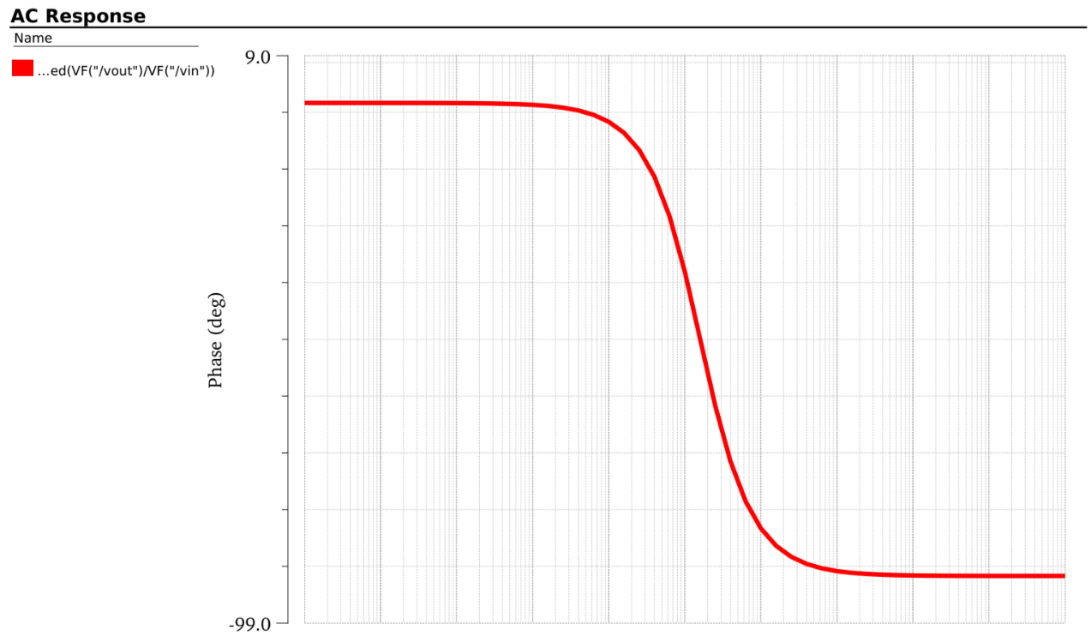 Fig : Phase Response of RC circuit

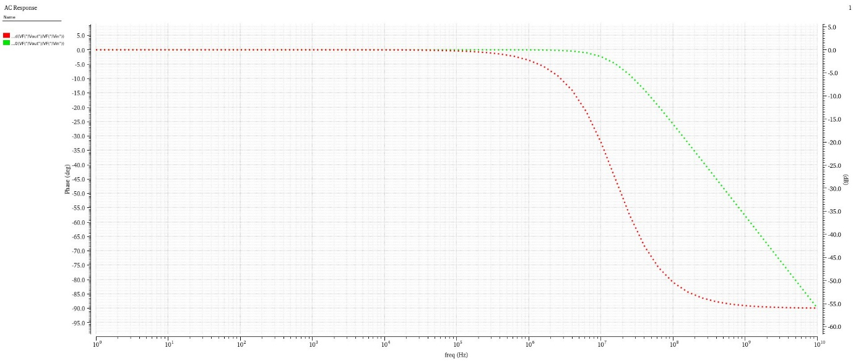

Fig : Phase Response of RC circuit

### Observation

1. **tp >> 5τ** :

The frequency of the square wave output is set low enough that the capacitor has ample time to fully charge and discharge during each cycle. As a result, the capacitor's voltage waveform closely follows the input square wave, reaching nearly the full supply voltage during charging and discharging phases. In this case, 𝑡 𝑝 t p ​ is set to 25τ, allowing the capacitor to behave as expected in an ideal scenario where the charging and discharging processes are complete before the next cycle begins.

1. **tp = 5τ** :

The capacitor has just enough time to fully charge and discharge during each pulse cycle. The voltage across the capacitor reaches approximately 0.63×Vin ​ (where Vin​ is the peak input voltage) during the charging phase and discharges to a similarly predictable level. This situation represents a balanced condition where the RC circuit transitions smoothly between charging and discharging within each pulse period.

1. **tp << 5τ** :

In this scenario, the capacitor does not have sufficient time to charge or discharge significantly before the next cycle begins. The voltage across the capacitor shows only minor variations, staying near the initial voltage level and never reaching the full supply voltage during the charging or discharging phases. This results in a waveform that barely rises during charging and quickly returns to the baseline during discharging, indicating that the RC circuit is operating under conditions where the pulse duration is too short for significant charging or discharging..

### Discussion

The results indicate that the time constant τ directly correlates with both resistance and capacitance values, confirming the theoretical understanding of RC circuits. The observed exponential behaviour in both charging and discharging phases aligns with the expected predictions of Kirchhoff’s laws.

The AC response revealed vital insights into the nature of impedance in RC circuits. The reduction in impedance with increasing frequency suggests that higher frequencies are attenuated less, making these circuits suitable for high-frequency applications. The phase angle data implies a significant capacitive reactance at lower frequencies, affecting signal processing in electronic systems which rely on precise timing

### conclusion

The experiment successfully elucidated the transient and AC response characteristics of RC circuits. The calculated time constants provided a clear understanding of charging and discharging behaviours, while the AC analysis highlighted the relationship between frequency and impedance.

Future recommendations include exploring more complex configurations such as RLC circuits to further analyse oscillatory behaviours and resonance effects. Additionally, investigations into non-ideal components, temperature effects, and real-world applications could enhance the understanding of circuit dynamics and improve design strategies in electronic systems.

# References

1. Jan M. Rabaey, “Digital Integrated Circuits- A Design Perspective”, Prentice Hall, Second Edition, 2005

2. Sung –Mo Kang & Yusuf Leblebici, “CMOS Digital Integrated Circuits- Analysis & Designing”, MGH, Third Ed., 2003

3. John P Uyemura, “Introduction to VLSI Circuits and Systems”, Wiley India, 2006

4. S K Gandhi, “VLSI Fabrication Principle”, John Wiley